Having had a sleepless night pondering the location of your picture I found I just couldn’t place it at Hammersmith Broadway, the corner layout was wrong for King Street / Beadon Hill (Met Line) and the shop fronts just would not fall in with any of my many photos of ‘old’ Hammersmith … so … despite the constant rain I got up this morning and armd with digicam took the car to Maida Hill (Westbourne Park) junction of Harrow Road, Fernhead Road, Walterton Road and Elgin Avenue. This site came to mind as soon as I saw the picture, having delivered mobile computer support in west London for many years before working at television centre I realised that I have sat at these lights more times than I care to remember!

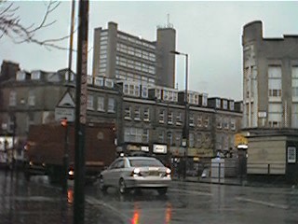
As I thought, this would mean that the trolley was heading south from Elgin Avenue at the Harrow Road junction, the all-night shop on the right and the two obelisks in front of it are now obscured by a ‘superloo’ but the pavement line is the same, the buildings on the left however have been cleared back to leave a open space, the ‘stink pipe’ sign post and crossing still exist though.

I have pasted in the original picture for comparison - what do you think?
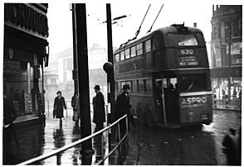
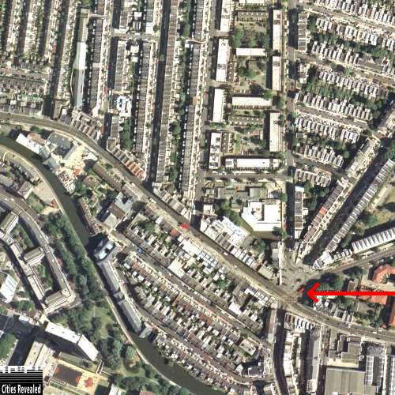

This is the
Junction

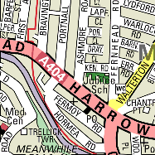

Hope I’m right and this clears up the
location mystery.

